SDK Design Document for Developers

Introduction
This document was prepared to explain the major piece of the SDK code generator design for developers. After reading this guide the code and technologies used to create SDK code generator will be laid bare. Developers can use this guide to start to get acquainted with the different packages that compose the SDK.

The SDK development code can be broken in three main parts, namely the code generator, the model validators and the model transformers. The generator owns the validators and transformers defined in SDK.

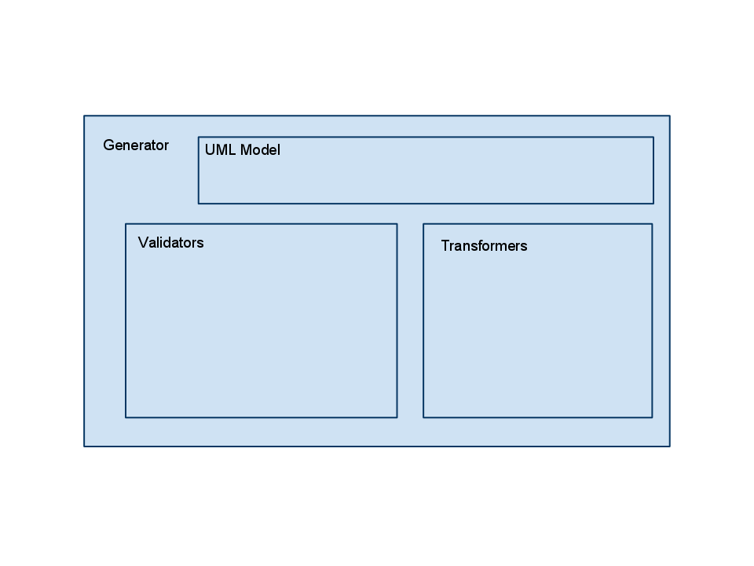
Figure 1: Conceptual model showing where various high level SDK code generation classes reside.

Additional Documentation
This document is a living document. Several documents exist before this one describing the SDK design and architecture. Most of the design documentation is release/project specific and only details the areas affected by that release. This document provides a summary of the design and references to other documentation. Please browse the documentation found in the following directories to get release specific information and detailed design.

.../projects/docs/SDK 4.4 docs/Development/Design/
.../projects/docs/SDK 4.0 docs/Development/Design/
.../projects/docs/SDK 3.2 docs/Development/Design/

SDK Generator
Generation involves the creation of artifacts from model. The general term for these activities is “Model Driven Engineering”. The SDK core class that orchestrates this activity is called Generator.

The SDK Generator can be found in the directory:

modules/codegen/src/gov/nih/nci/codegen/

Generator represents the entry point of the SDK code generator. It ties together the activities of validation classes with model transforming classes. The SDK generator loads these classes at run time via a Spring Framework configuration file. Spring is a dependency injection framework the can be found at:

www.springframework.org

The generation workflow described by the Generator is a simple one. Essentially, the Generator executes generic model validation classes against the model. It reports any errors discovered at this point. If no errors are found, the Generator then executes transformer specific validation against the model. If this completes without failures, the generator finally executes the transformation logic in the “execute” method of each of the transformers.

Validation and transformation classes are handled in the next section.

Validation Classes
Validation involves verification of correctness of a UML model. This means that the UML model itself does not contain structural issues, as well that the SDK specific tags that the user has used to annotate the model with additional semantics make sense.
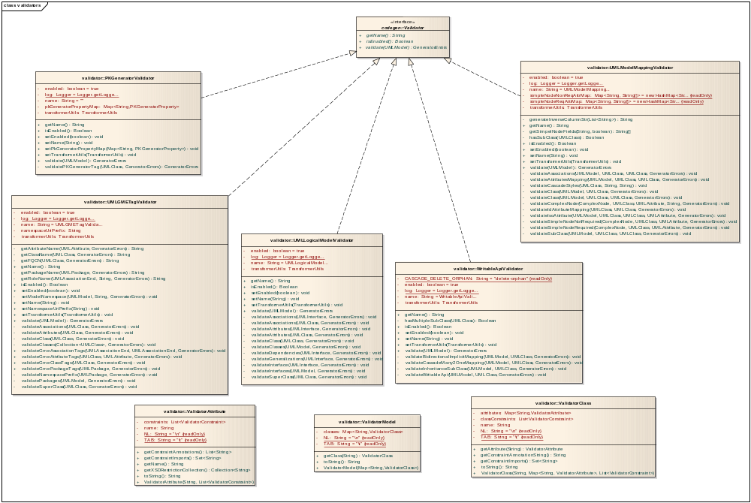
Figure 2: SDK code generator UML Model validation classes

The SDK team has already defined the following generic model validation classes:

- LogicalModelValidator - Validates the semantic correctness of a UML model.
- ModelMappingValidator - validates the model mappings between a logical model and a data model.
- PKGeneratorValidator - validates the correctness of primary key generation.
- WritableApiValidator
- GMETagValidator

Transformer Classes
By design, transformer convert UML Model elements into generated artifacts. Artifacts could be Java files, configuration code, or build support. These classes can be found in the transformer directory in the SDK build “modules/codegen/src/gov/nih/nci/codegen/transformer”.

Transformers
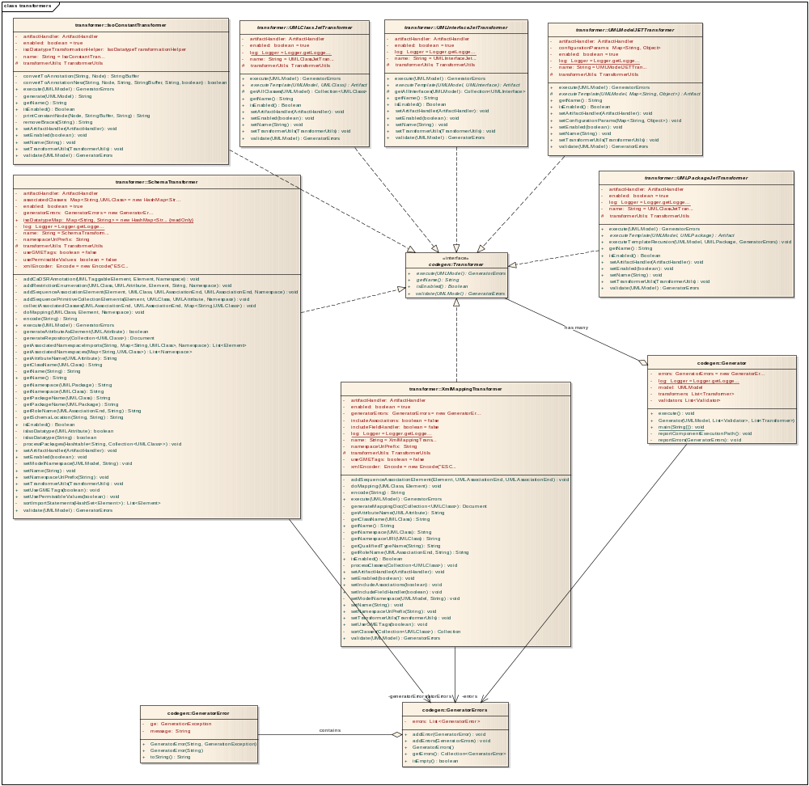
Figure 3: SDK code generator Transformer classes

Transformers implement the Transformer interface, which is defined in the java package “gov.nih.nci.codegen”. The Transformer interface describes methods for validating a model, as well as executing the generation phase to create artifacts. Most transformers follow this routine, with helper classes used to provide the specific functionality that depends on the type of artifact being created.

The following is a list of the transformers that are defined today:

- IsoConstantTransformer.java - Used to convert ISO 21090 defined model values into Java classes.
- SchemaTransformer.java - Produces an XML schema from the UML model.
- UMLClassJetTransformer.java - Produces Java classes from the classes defined in the UML model.
- UMLInterfaceJetTransformer.java - Produces Java interfaces from the interfaces defined in the UML Model.
- UMLModelJETTransformer.java
- UMLPackageJetTransformer.java
- XmlMappingTransformer.java

Templating
SDK code generators use templates to directly generate code fragments, documents, configuration, and other artifacts in conjunction to a consumed data model. Users of the SDK can describe their domain model using Enterprise Architect based UML. The UML is then annotated with SDK specific code generation directives called “tagged values”. These tag values contain information that the SDK code generator uses to specify the kind of artifacts that should be generated.

When creating these artifacts, templates represent the final say on the writing of an artifact to disk. A template contains structural information pertaining to the shape and content of a particular artifacts.

Templates provide hooks into the template structure. These hooks can be thought of as holes, in which developer’s may specify the values that will be placed in the template document. A template may be reused many times upon its inception.

SDK uses the JET templating framework to implement common templating functionality. JET templates work in a similar fashion to Java Server Pages (JSP). JET templates are currently used by several large organizations (such as the Mozilla foundation) to provide templates for Java developers. For more information about JET templates see the following URI:

http://www.eclipse.org/articles/Article-JET/jet_tutorial1.html

In the SDK build, JET templates are found in files with a “javajet” extension. They are located in the directory “modules/codegen-templates/templates”.

Technology Dependencies
The SDK code generator generates code that supports web services that can access data in a database that matches the description provided in the UML model. To accomplish this task, SDK relies on an array of supporting open source technologies that are widely used in the industry. A treatment of these technologies follows.
EHCache
EHCache is a distributed caching technologies that can be used to cache strings (web pages, template fragments) and serializable objects (database results, java instance objects) with the intent of improving computational and I/O performance. EHCache is widely used in the Java world, and has substatial documentation defining how it works. More about EHCache can be found here at www.ehcache.org.
Hibernate
Hibernate is a first class Java object relational mapping tool created by Gavin King. Hibernate supports a variety of RDBMS databases. More about hibernate can be found at www.hibernate.org.
JAXB
JAXB is the Java Architecture for XML binding. The SDK generator uses JAXB for effecting XML to object transformation and bindings. JAXB is developed by Oracle. More on JAXB can be found at www.oracle.com/technetwork/articles/javase/index-140168.html#introjb

CQL
CQL stands for the Contextual Query Language. It was developed with the intent of allowing non developers to gain the ability express queries to information retrieval systems. More about CQL can be found at www.loc.gov/standards/sru/specs/cql.html.
X.509 certificates
X.509 is a standard for representing public key encryption infrastructure to support single sign on and privilege management. More about X.509 can be found here en.wikipedia.org/wiki/X.509.
Acegi
Acegi is a Spring based security system for Java based applications. As a point of fact, going forward Acegi is now referred to as Spring Security. Acegi provides support for a variety of security related activities such as OpenId, WSS (WS- Security, and Access Control Lists (ACL). More can be learned about Acegi at http://www.acegisecurity.org.
Bouncy Castle
Bouncy Castle provides encryption utilities to support the implementation of X.509 certificates, TLS, PGP, and other security protocols. You can learn more about the Bouncy Castle libraries at www.bouncycastle.org.
Tomcat
Tomcat is a Java servlet container that is widely used. SDK code generator creates services that can be deployed to Tomcat. More information regarding Tomcat could be found at tomcat.apache.org.
JBoss
Jboss is a Java servlet container that is widely used. SDK code generator creates services that can be deployed to JBoss. More information regarding JBoss could be found at jboss.org.
Log4j
Log4J is the login utility of choice for SDK. More on log4j logging.apache.org.
Castor
Castor is an XML binding utility used to convert XML fragments to object classes. Learn more about Castor at castor.org.

Appendix
The following diagrams illustrate the main packages of the SDK code generator which are the transformer and validation classes as well as the SDK code generator itself.

SDK Design Model
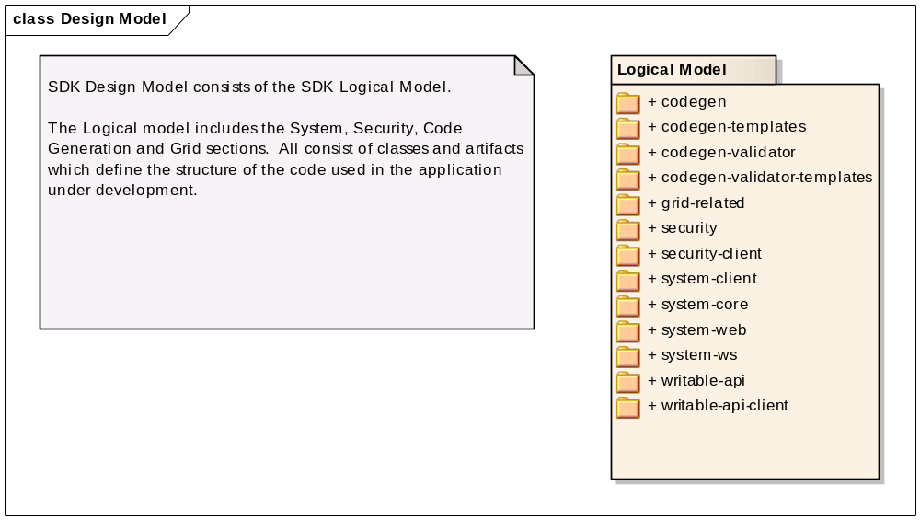
Code Gen Model
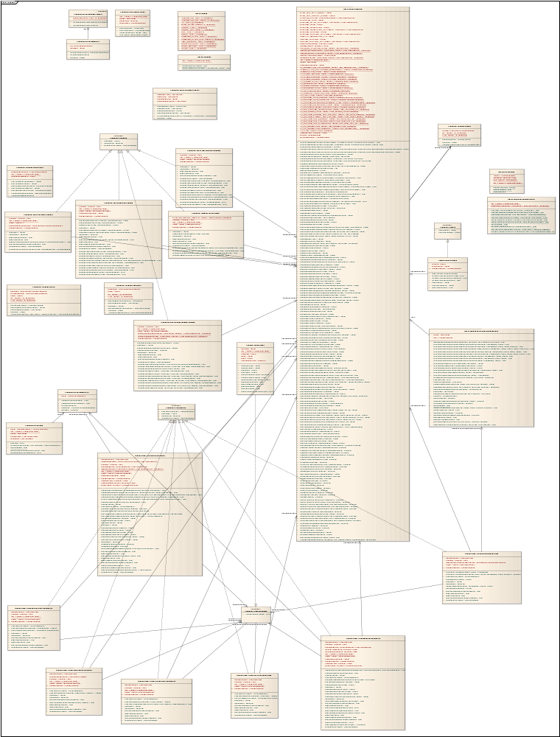
Code Gen Templates and Validators Model
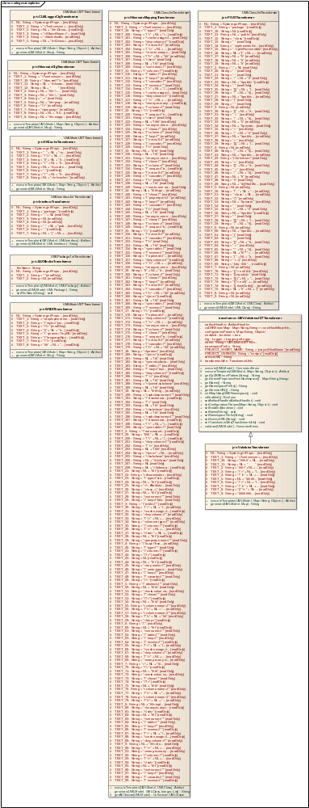
Grid related
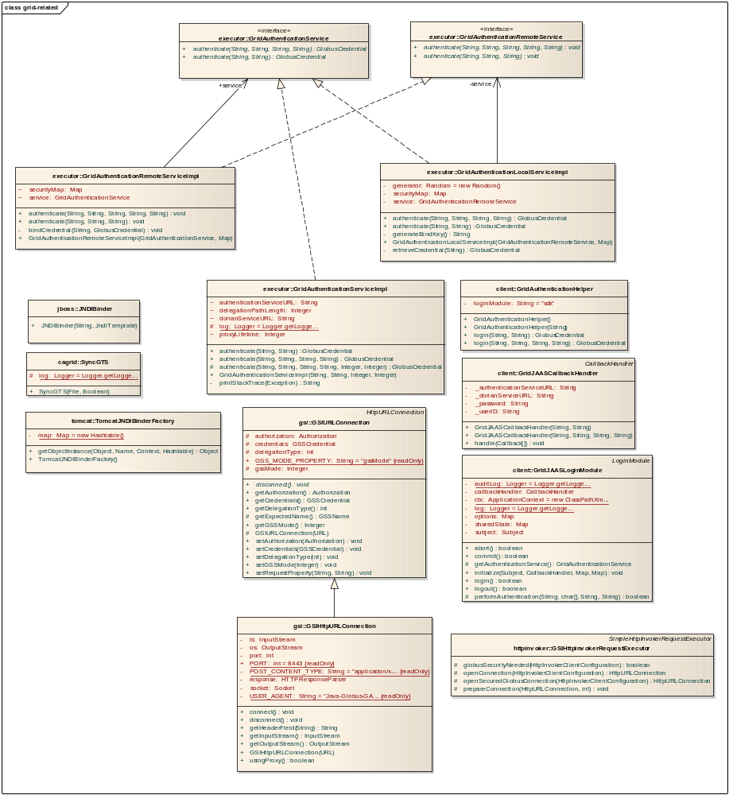
Security Model
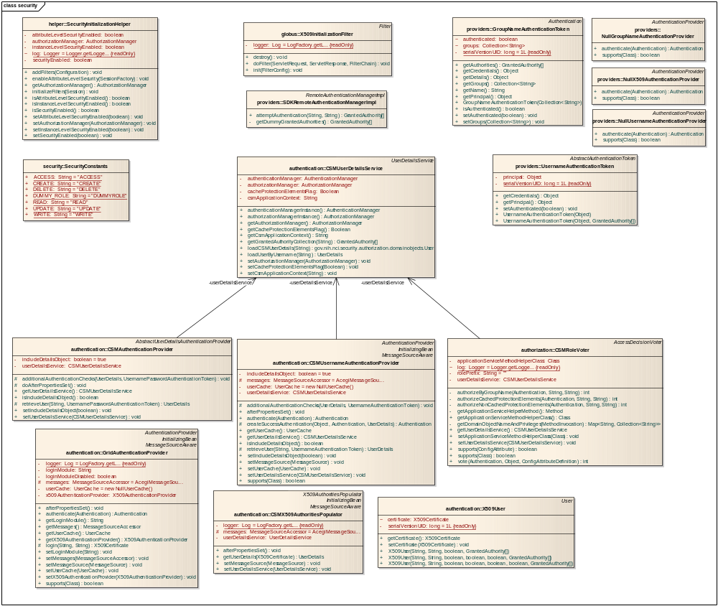
Security Client Model
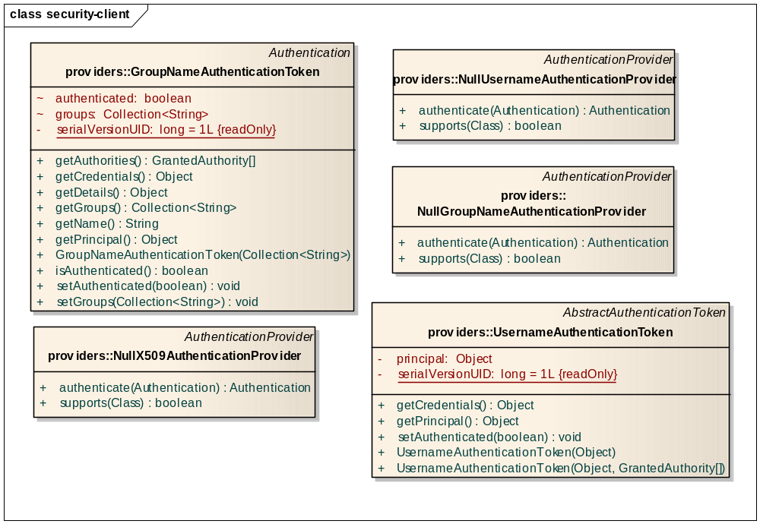

System Client Model
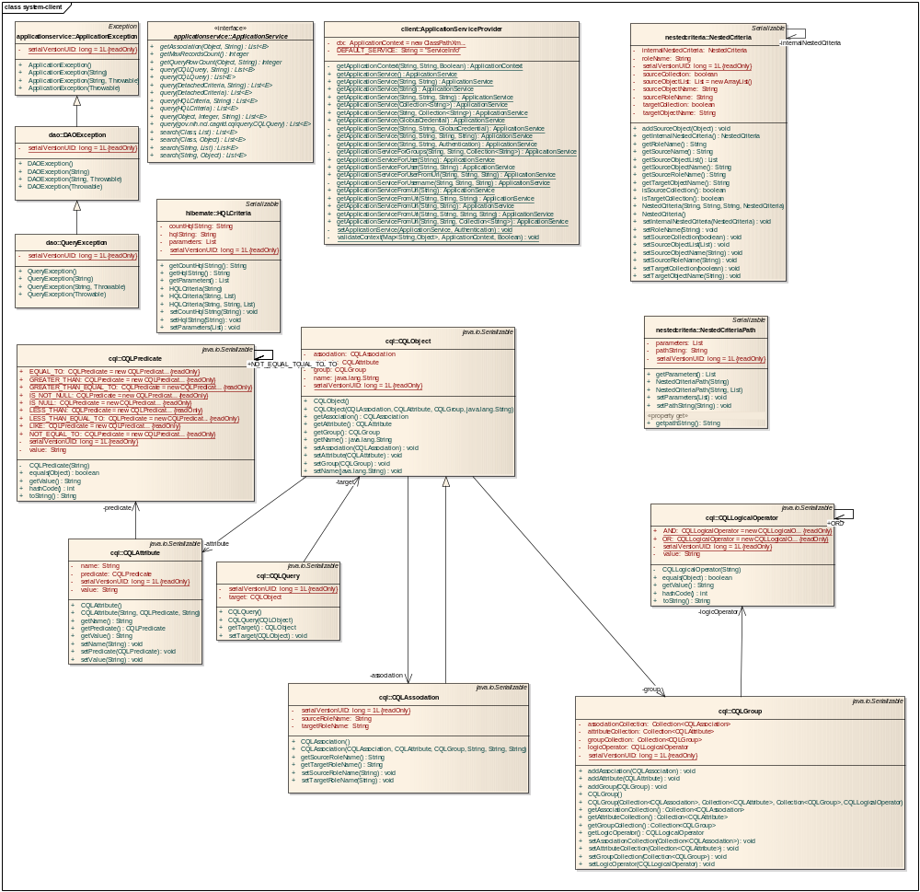
System Core Model
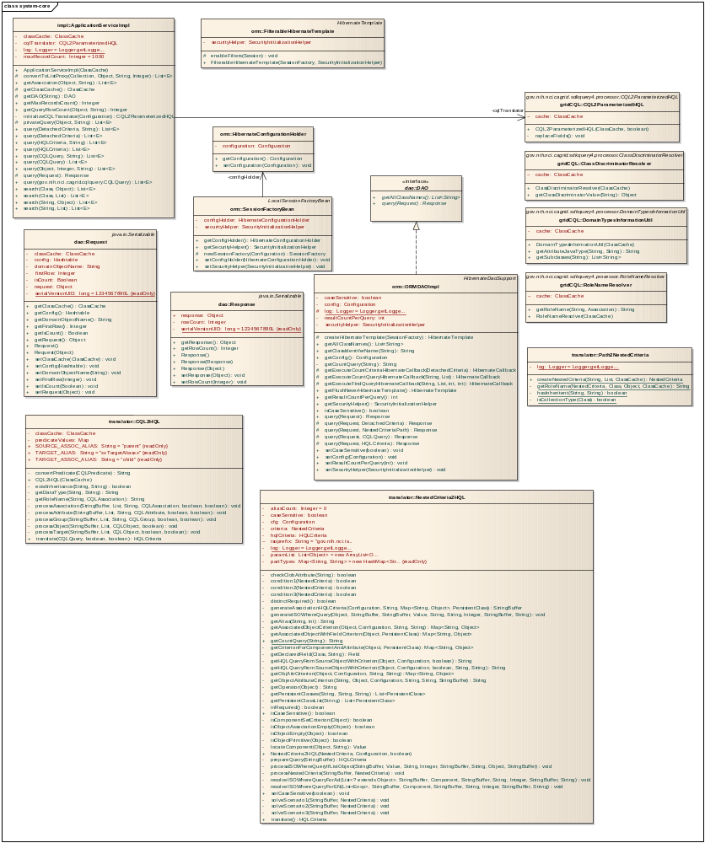
System Web Model
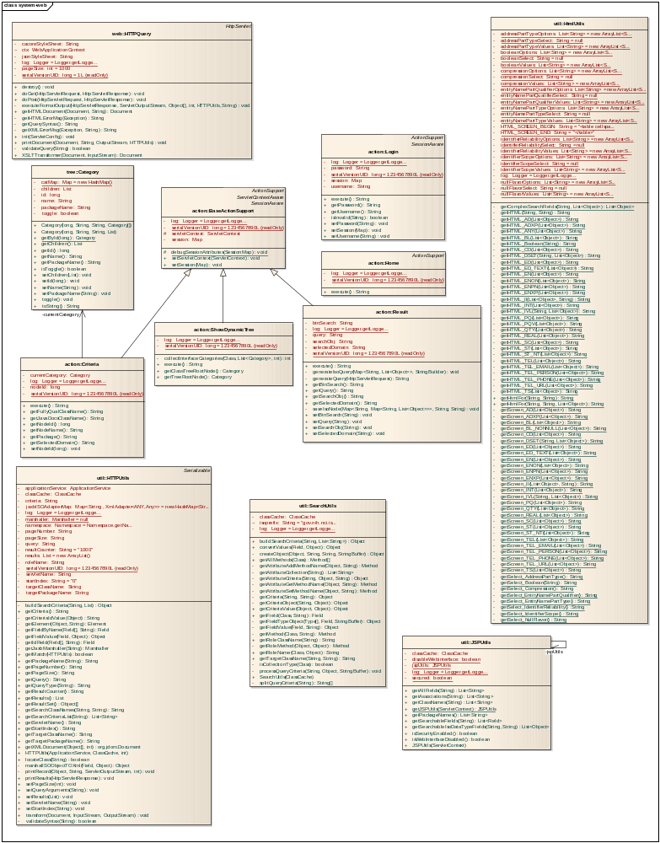
System WS Model
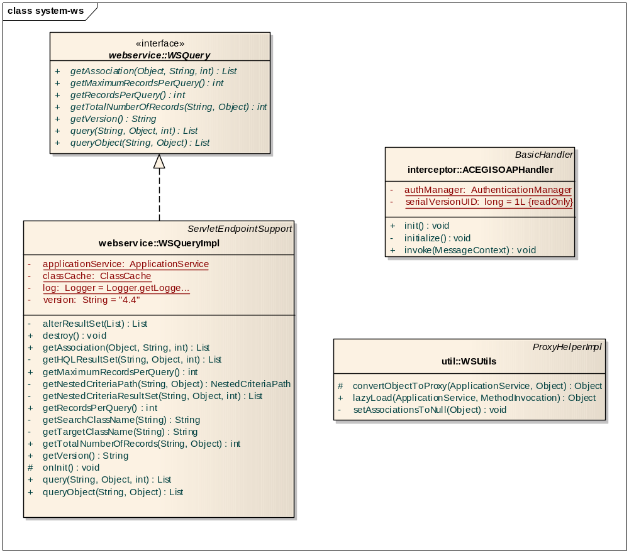
Writable API Model
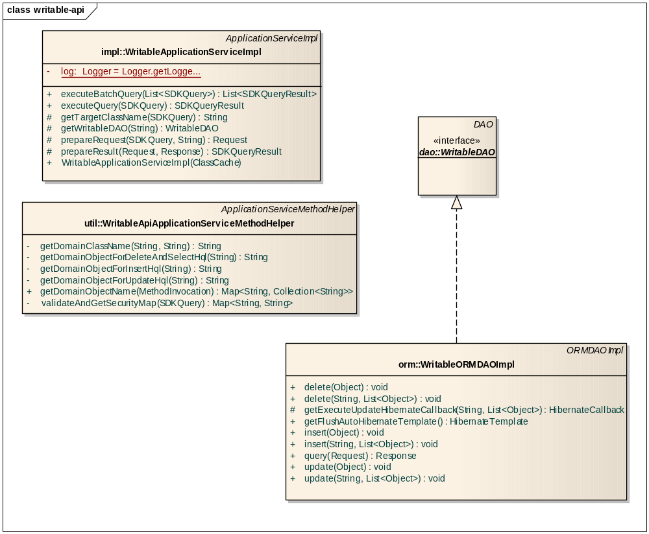
Writable-API Client Model
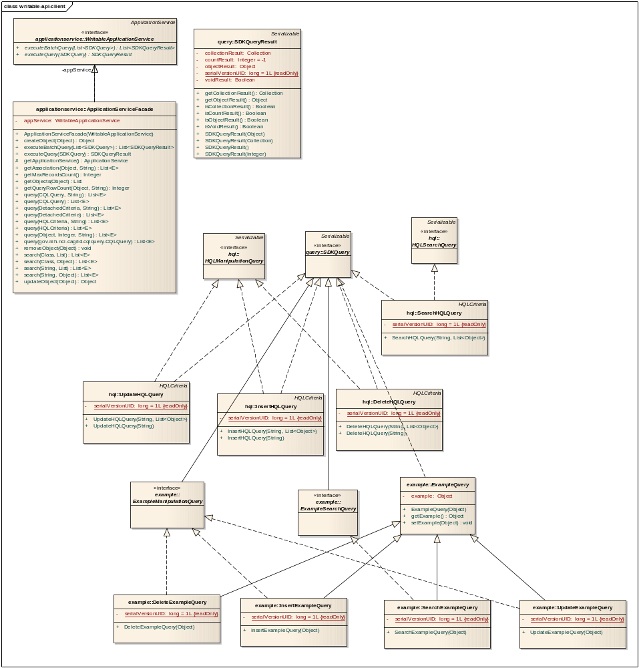

http://en.wikipedia.org/wiki/Dependency_injection
One type of helper class is the ArtifactHandler. The only concrete class that implements the ArtifactHandler at the time of this documents creation is the FileHandler class. The FileHandler class provides file writing support for Transformer classes.

